DATE : June 16, 2026
TO : Marlon Jr Aquino Mullet
POSITION : Travel Consultant
EID : 22052545
SITE : M5
FROM : ATAIN
SUBJECT : RESIGNATION ACCEPTANCE LETTER (RAL)
This is to acknowledge the receipt of your resignation letter dated 5/26/2026 effective on 5/26/2026. In compliance with the thirty (30)-day notice period stated in clause V of your employment contract and Labor Code of the Philippines, your resignation is deemed accepted provided that your last working day shall be on 5/26/2026.
Until the effective date granted above, you shall remain to be an employee of IGT Technologies Philippines Inc., and you are expected to remain in adherence to the company’s policies and procedures.
Any unauthorized/unexcused absence post acceptance shall be deemed to be non-compliant to the notice period completion. The Company as an effect shall be forced to impose provisions stated in your contract, which states:
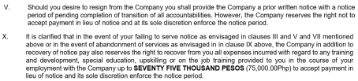
“Liquidated damages equivalent to the number of days you failed to complete in the thirty (30) day notice requirement, e.g., failure to render 15 days out of the 30-day notice period, we shall deduct one-half (½) of your basic salary.”
The liquidated damages as stated above shall be deducted from your full and final pay. In the event, full and final pay is not sufficient, you shall endeavor to settle the full amount. The company shall pursue all legal means to recover the amount from the employee.
Please be reminded also that you are expected to process your clearance within seven (7) days after your last working date/ separation date. Your failure to initiate this process may impact the timeline to process your last claims from the Company. You are hereby ordered to surrender all company-related materials and undergo the exit process in accordance with the company policy; otherwise, all of these shall be recovered from your full and final settlement. Your full and final pay will be made available in (30) days upon full satisfaction of the company’s exit clearance process.

Received by:
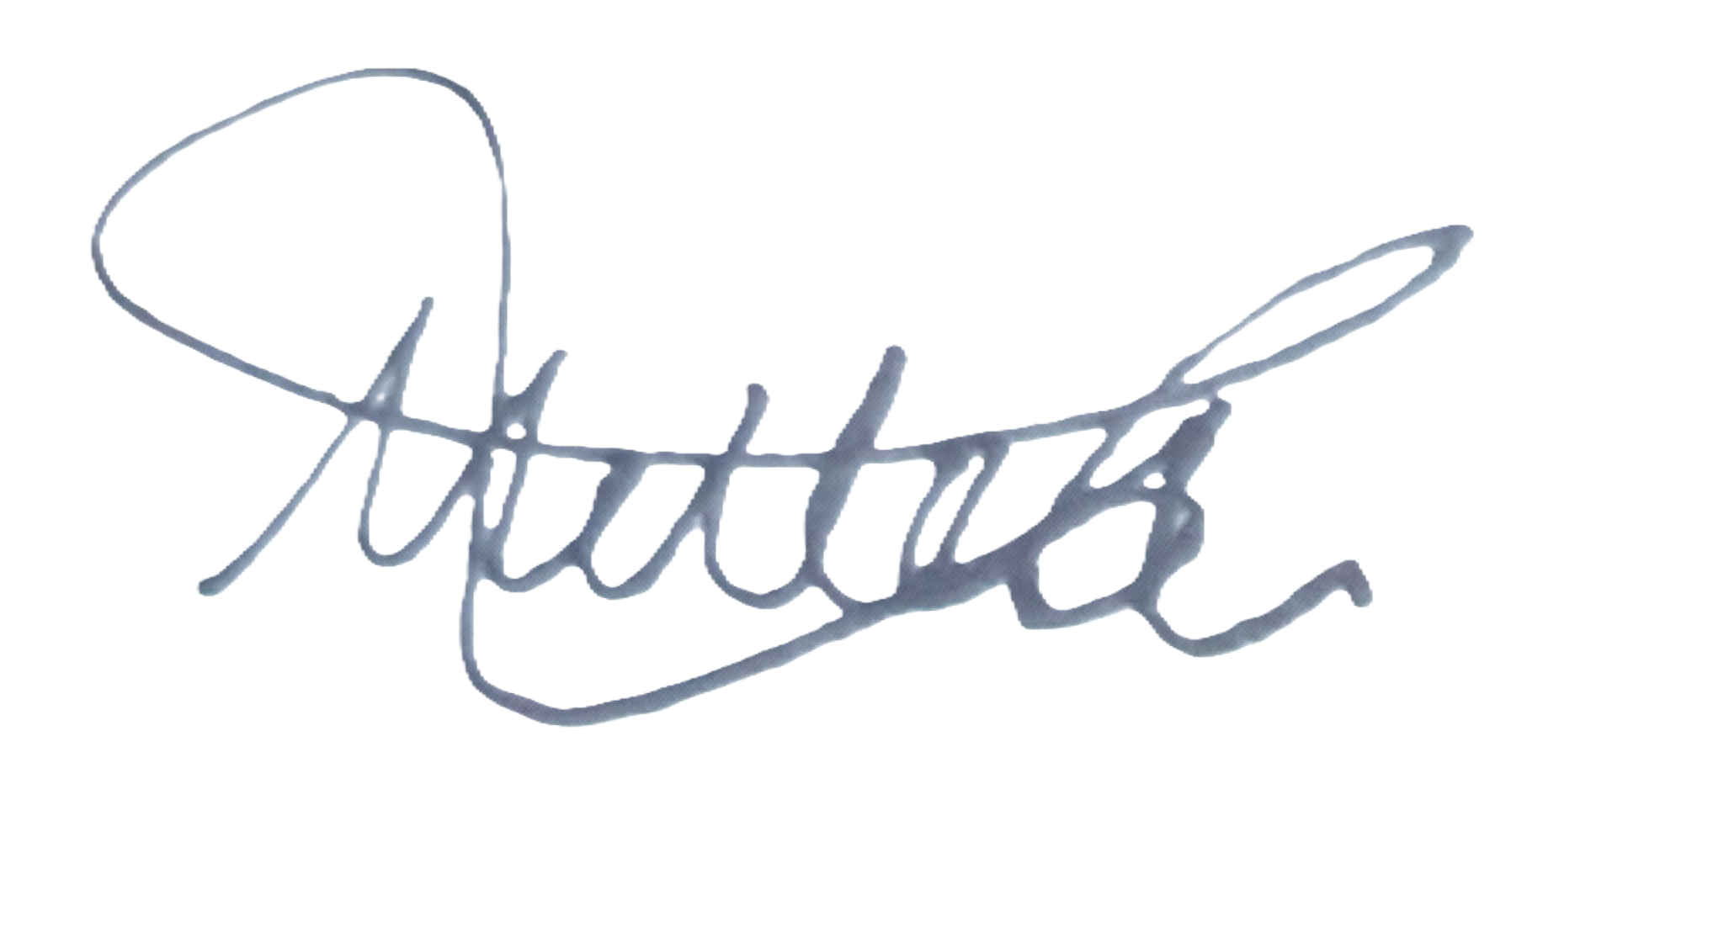
MULLET, MARLON JR A.
Signature over printed name
Date and Time: 06/27/2026 Contact #: +63925917931
© Atain | Confidential: Not for Distribution | www.atain.com

